网络安全
实验报告

专 业：通信工程
班级学号：20210924
姓 名：杨宇烨
指导教师：张海蓉
日 期：2023/11/9

实验一 古典密码算法实现
一、实验目的
掌握古典密码学一般原理，理解 Shannon 扩散、混淆的密码设计思想及代换、置换方法；掌握恺撒密码、维吉尼亚密码、弗纳姆密码、置换密码等典型的古典密码原理及实现。
二、实验内容、代码和结果
1、题目：编程实现单表代换密码的代表算法恺撒密码的加密解密过程。

代码：
std::string caesar::caesarEncrypt(const std::string& M, int n) {
std::string C = M;
int len = C.length();
for (int i = 0; i < len; i++) {
if (isalpha(C[i])) {
if (islower(C[i])) {
C[i] = 'a' + (C[i] - 'a' + n) % 26;
} else {
C[i] = 'A' + (C[i] - 'A' + n) % 26;
}
}
}
return C;
}
std::string caesar::caesarDecrypt(const std::string& C, int n) {
std::string M = C;
int len = M.length();
for (int i = 0; i < len; i++) {
if (isalpha(M[i])) {
if (islower(M[i])) {
M[i] = 'a' + (M[i] - 'a' - n + 26) % 26;
} else {
M[i] = 'A' + (M[i] - 'A' - n + 26) % 26;
}
}
}
return M;
}
void run_caesar(){
int choose;
string str;
int n;
cout<<"-------------------------"<<endl;
cout<<"*choose mode *"<<endl;
cout<<"*1.Encryption *"<<endl;
cout<<"*2.Decryption *"<<endl;
cout<<"-------------------------"<<endl;
cout<<"you choose:";
cin>>choose;
if(choose==1)
{
cout<<"passage:";
cin>>str;
cout<<"key:";
cin>>n;
caesar a(str,Encryption);
cout<<"result:"<<a.caesarEncrypt(a.M,n)<<endl;
}
else if(choose==2)
{
cout<<"passage:";
cin>>str;
cout<<"key:";
cin>>n;
caesar a(str,Decryption);
cout<<"result:"<<a.caesarDecrypt(a.C,n)<<endl;
}
else{cerr<<"wrong number";}
}

实验结果（抓屏）：
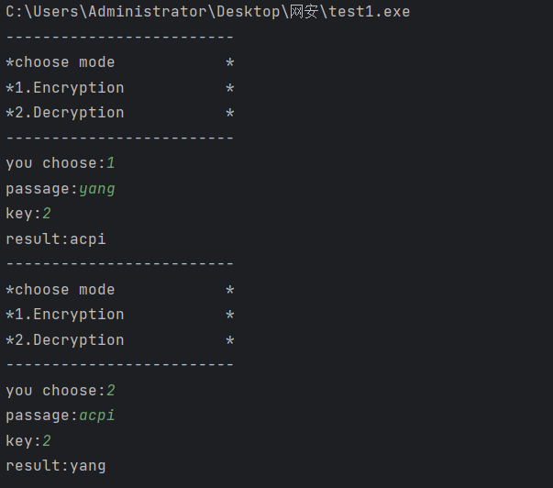
2、题目：编程实现多表代换密码的代表算法维吉尼亚密码的加密解密过程

代码：
std::string vigenere::vigenereEncrypt(const std::string& M, const std::string& key) {
std::string C = M;
int len = C.length();
int keyLen = key.length();
for (int i = 0; i < len; i++) {
if (isalpha(C[i])) {
if (islower(C[i])) {
C[i] = 'a' + (C[i] - 'a' + (key[i % keyLen] - 'a')) % 26;
} else {
C[i] = 'A' + (C[i] - 'A' + (key[i % keyLen] - 'a')) % 26;
}
}
}
return C;
}
std::string vigenere::vigenereDecrypt(const std::string& C, const std::string& key) {
std::string M = C;
int len = M.length();
int keyLen = key.length();
for (int i = 0; i < len; i++) {
if (isalpha(M[i])) {
if (islower(M[i])) {
M[i] = 'a' + (M[i] - 'a' - (key[i % keyLen] - 'a') + 26) % 26;
} else {
M[i] = 'A' + (M[i] - 'A' - (key[i % keyLen] - 'a') + 26) % 26;
}
}
}
return M;
}
void run_vigenere(){
int choose;
string str;
string n;
cout<<"-------------------------"<<endl;
cout<<"*choose mode *"<<endl;
cout<<"*1.Encryption *"<<endl;
cout<<"*2.Decryption *"<<endl;
cout<<"-------------------------"<<endl;
cout<<"you choose:";
cin>>choose;
cout<<"passage:";
cin>>str;
cout<<"key:";
cin>>n;
vigenere b;
if(choose==1)
{
cout<<"result:"<<b.vigenereEncrypt(str,n)<<endl;
}
else if(choose==2)
{
cout<<"result:"<<b.vigenereDecrypt(str,n)<<endl;
}
else{cerr<<"wrong number";}
}

实验结果（抓屏）：
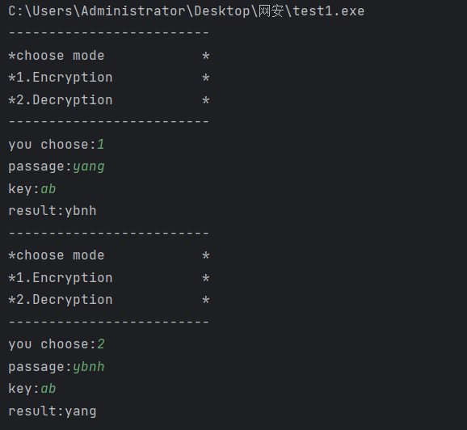
3、题目：编程实现流密码初步弗纳姆密码的加密解密过程。
代码：
std::string vernamEncryptDecryptBinary(const std::string& str, const std::string& key) {
std::string result;
int strLen = str.length();
int keyLen = key.length();
for (int i = 0; i < strLen; i++) {
char encryptedChar = str[i] ^ key[i % keyLen];
result += encryptedChar;
}
return result;
}
int run_vernam() {
std::string plaintext ;
std::string key ;
cout<<"passage:";
cin>>plaintext;
cout<<"key:";
cin>>key;
std::string ciphertextBinary = vernamEncryptDecryptBinary(plaintext, key);
std::cout << "Binary Ciphertext: " << ciphertextBinary << std::endl;
std::string decryptedTextBinary = vernamEncryptDecryptBinary(ciphertextBinary, key);
std::cout << "Binary Decrypted Text: " << decryptedTextBinary << std::endl;
return 0;
}

实验结果（抓屏）：
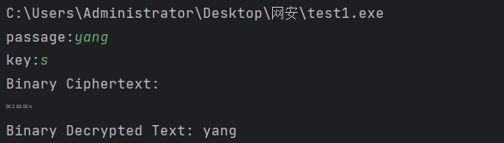
4、题目：编程实现置换密码的加密解密过程。
代码：
void substitution::substitution_(const std::string& str, const std::string& key) {
int cols=key.length();
vector<char> arr;
for (auto it:key) {
arr.push_back(it);
}
std::sort(arr.begin(), arr.end());
int rows=0;
while(cols*rows<str.length())rows++;
// char output[rows][cols];
for (int i = 0; i < rows; ++i) {
for (int j = 0; j < cols; ++j) {
if(i*cols+key.find(arr[j])<str.length())
cout<<str[i*cols+key.find(arr[j])];
}
}cout<<endl;
}
void run_substitution(){
int choose;
string str;
string n;
cout<<"passage:";
cin>>str;
cout<<"key:";
cin>>n;
substitution b;
cout<<"result:";
b.substitution_(str,n);
}

实验结果（抓屏）：
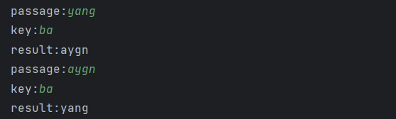
三、实验中遇到的问题及解决方案
在写置换密码时想重新写一个二维矩阵把密文重新放进去，但是想想直接用一阶矩阵固定间隔读取可以模拟二维矩阵读取列的过程。

实验二 DES 单钥密码算法实现
一、实验目的
掌握单钥密码体制一般原理，重点掌握经典分组密码 DES 算法的原理及实现；理解单 钥密码体制在网络安全通信中的作用。
二、实验内容、代码和结果
1、题目：
1. 编程实现 DES 算法的子密钥生成。
2. 编程实现 DES 算法的 S 盒替换。
3. 编程实现 DES 算法的 P 盒替换。
(选作)4. 编程实现 DES 算法的加密解密完整过程。

代码：
//
// Created by Administrator on 2023/11/7.
//
#define _CRT_SECURE_NO_WARNINGS
#include<iostream>
#include <bitset>
#include<string>
#include <cstdio>
#include"num.h"

void get_key() {
for (i = 0; i < 8; i++)
{
int a[8] = { 0,0,0,0,0,0,0,0 };
m = InputKey[i];
for (j = 0; m != 0; j++)
{
a[j] = m % 2;
m = m / 2;
}
for (j = 0; j < 8; j++)
key[(i * 8) + j] = a[7 - j];
}

printf("64bit key: ");
for (i = 0; i < 64; i++)
printf("%d", key[i]);
printf("\n");
}
void encrypt() {
printf("passage: \n");
gets_s(MingWen, sizeof(MingWen));
while (MingWen[0] == '\0')
{
printf("wrong\n");
gets_s(MingWen, sizeof(MingWen));
}

i = 0;
n = 0;
while (MingWen[i] != '\0')
{
n++;
i++;
}
k = n % 8;
n = (n - 1) / 8 + 1;

for (l = 0; l < n; l++)
{
if (l == (n - 1) && k != 0)
{
for (i = 0; i < k; i++)
target[i] = MingWen[i + (8 * l)];
for (i = k; i < 8; i++)
target[i] = ' ';
}
else
for (i = 0; i < 8; i++)
target[i] = MingWen[i + (8 * l)];

for (i = 0; i < 8; i++)
{
int a[8] = { 0,0,0,0,0,0,0,0 };
m = target[i];
for (j = 0; m != 0; j++)
{
a[j] = m % 2;
m = m / 2;
}
for (j = 0; j < 8; j++)
text[(i * 8) + j] = a[7 - j];
}

for (i = 0; i < 64; i++)
text[i] = text_out[l][i] ^ text[i];

for (i = 0; i < 64; i++)
text_ip[i] = text[IP[i] - 1];

for (i = 0; i < 32; i++)
{
L0[i] = text_ip[i];
R0[i] = text_ip[i + 32];
}

for (t = 0; t < 16; t++)
{
for (i = 0; i < 48; i++)
RE0[i] = R0[E[i] - 1];

for (i = 0; i < 48; i++)
RK[i] = RE0[i] ^ K[t][i];

for (i = 0; i < 8; i++)
{
r[i] = RK[(i * 6) + 0] * 2 + RK[(i * 6) + 5];
c[i] = RK[(i * 6) + 1] * 8 + RK[(i * 6) + 2] * 4 + RK[(i * 6) + 3] * 2 + RK[(i * 6) + 4];
}
RKS[0] = S1[r[0]][c[0]];
RKS[1] = S2[r[1]][c[1]];
RKS[2] = S3[r[2]][c[2]];
RKS[3] = S4[r[3]][c[3]];
RKS[4] = S5[r[4]][c[4]];
RKS[5] = S6[r[5]][c[5]];
RKS[6] = S7[r[6]][c[6]];
RKS[7] = S8[r[7]][c[7]];

for (i = 0; i < 8; i++)
{
int b[4] = { 0,0,0,0 };
m = RKS[i];
for (j = 3; m != 0; j--)
{
b[j] = m % 2;
m = m / 2;
}
for (j = 0; j < 4; j++)
SP[j + (i * 4)] = b[j];
}

for (i = 0; i < 32; i++)
RKSP[i] = SP[P[i] - 1];

for (i = 0; i < 32; i++)
Ri[i] = L0[i] ^ RKSP[i];

for (i = 0; i < 32; i++)
{
L0[i] = R0[i];
R0[i] = Ri[i];
}
}

for (i = 0; i < 32; i++)
Li[i] = R0[i];
for (i = 0; i < 32; i++)
R0[i] = L0[i];
for (i = 0; i < 32; i++)
L0[i] = Li[i];

for (i = 0; i < 32; i++)
text_end[i] = L0[i];
for (i = 32; i < 64; i++)
text_end[i] = R0[i - 32];

for (i = 0; i < 64; i++)
text_out[l + 1][IP[i] - 1] = text_end[i];

for (i = 0; i < 64; i++)
result[l][i] = text_out[l + 1][i];

}

for (j = 0; j < n; j++)
for (i = 0; i < 16; i++)
H[i + (j * 16)] = result[j][0 + (i * 4)] * 8 + result[j][1 + (i * 4)] * 4 + result[j][2 + (i * 4)] * 2 + result[j][3 + (i * 4)];

for (i = 0; i < n * 16; i++)
{
if (H[i] < 10)
MiWen[i] = H[i] + 48;
else if (H[i] == 10)
MiWen[i] = 'A';
else if (H[i] == 11)
MiWen[i] = 'B';
else if (H[i] == 12)
MiWen[i] = 'C';
else if (H[i] == 13)
MiWen[i] = 'D';
else if (H[i] == 14)
MiWen[i] = 'E';
else if (H[i] == 15)
MiWen[i] = 'F';
}
for (i = l * 16; i < 208; i++)
MiWen[i] = '\0';

printf("after des:\n");
printf("%s\n", MiWen);
printf("\n\n");
}

void decrypt() {

printf("passage: \n");
gets_s(MiWen, sizeof(MiWen));

for (i = 0; i < 208; i++)
H[i] = 0;

for (i = 0; MiWen[i] != '\0'; i++)
{
if (MiWen[i] >= '0' && MiWen[i] <= '9')
H[i] = MiWen[i] - '0';
else if (MiWen[i] >= 'A' && MiWen[i] <= 'F')
H[i] = MiWen[i] - 'A' + 10;
else if (MiWen[i] >= 'a' && MiWen[i] <= 'f')
H[i] = MiWen[i] - 'a' + 10;
else
{
printf("OX passage: \n");
gets_s(MiWen, sizeof(MiWen));
i = 0;
}
}
n = i;
if (n % 16 != 0)
{
printf("密文不正确,密文的字符数应是16的倍数。\n");
printf("passage: \n");
gets_s(MiWen, sizeof(MiWen));

for (i = 0; i < 208; i++)
H[i] = 0;
for (i = 0; MiWen[i] != '\0'; i++)
{
if (MiWen[i] >= '0' && MiWen[i] <= '9')
H[i] = MiWen[i] - '0';
else if (MiWen[i] >= 'A' && MiWen[i] <= 'F')
H[i] = MiWen[i] - 'A' + 10;
else if (MiWen[i] >= 'a' && MiWen[i] <= 'f')
H[i] = MiWen[i] - 'a' + 10;
}
}

for (i = 0; i < n; i++)
{
int he[4] = { 0,0,0,0 };
for (j = 3; H[i] != 0; j--)
{
he[j] = H[i] % 2;
H[i] = H[i] / 2;
}
for (j = 0; j < 4; j++)
C[j + (i * 4)] = he[j];
}

k = n / 16;
for (l = 0; l < k; l++)
{
for (i = 0; i < 64; i++)
text_out[l + 1][i] = C[i + (l * 64)];

for (i = 0; i < 64; i++)
text_ip[i] = text_out[l + 1][IP[i] - 1];

for (i = 0; i < 32; i++)
{
L0[i] = text_ip[i];
R0[i] = text_ip[i + 32];
}

for (t = 0; t < 16; t++)
{
for (i = 0; i < 48; i++)
RE0[i] = R0[E[i] - 1];

for (i = 0; i < 48; i++)
RK[i] = RE0[i] ^ K[15 - t][i];

for (i = 0; i < 8; i++)
{
r[i] = RK[(i * 6) + 0] * 2 + RK[(i * 6) + 5];
c[i] = RK[(i * 6) + 1] * 8 + RK[(i * 6) + 2] * 4 + RK[(i * 6) + 3] * 2 + RK[(i * 6) + 4];
}

RKS[0] = S1[r[0]][c[0]];
RKS[1] = S2[r[1]][c[1]];
RKS[2] = S3[r[2]][c[2]];
RKS[3] = S4[r[3]][c[3]];
RKS[4] = S5[r[4]][c[4]];
RKS[5] = S6[r[5]][c[5]];
RKS[6] = S7[r[6]][c[6]];
RKS[7] = S8[r[7]][c[7]];

for (i = 0; i < 8; i++)
{
int b[4] = { 0,0,0,0 };
m = RKS[i];
for (j = 3; m != 0; j--)
{
b[j] = m % 2;
m = m / 2;
}
for (j = 0; j < 4; j++)
SP[j + (i * 4)] = b[j];
}

for (i = 0; i < 32; i++)
RKSP[i] = SP[P[i] - 1];

for (i = 0; i < 32; i++)
Ri[i] = L0[i] ^ RKSP[i];

for (i = 0; i < 32; i++)
{
L0[i] = R0[i];
R0[i] = Ri[i];
}
}

for (i = 0; i < 32; i++)
Li[i] = R0[i];
for (i = 0; i < 32; i++)
R0[i] = L0[i];
for (i = 0; i < 32; i++)
L0[i] = Li[i];

for (i = 0; i < 32; i++)
text_end[i] = L0[i];
for (i = 32; i < 64; i++)
text_end[i] = R0[i - 32];

for (i = 0; i < 64; i++)
text[IP[i] - 1] = text_end[i];

for (i = 0; i < 64; i++)
result[l][i] = text_out[l][i] ^ text[i];

}

for (i = 0; i < (n / 16); i++)
for (j = 0; j < 8; j++)
M[i][j] = result[i][(j * 8) + 0] * 128 + result[i][(j * 8) + 1] * 64 + result[i][(j * 8) + 2] * 32 + result[i][(j * 8) + 3] * 16 + result[i][(j * 8) + 4] * 8 + result[i][(j * 8) + 5] * 4 + result[i][(j * 8) + 6] * 2 + result[i][(j * 8) + 7];

printf("After DES\n");
for (i = 0; i < (n / 16); i++)
for (j = 0; j < 8; j++)
printf("%c", M[i][j]);
printf("\n\n\n");
}

void encryptAnddecrypt() {
if (choice == 'A' || choice == 'a')
{
encrypt();
}
else if (choice == 'B' || choice == 'b')
{
decrypt();
}
}

int main()
{

while (flag)
{
printf("/*******************\\\n");
printf("* des加密/des解密 *\n");
printf("* A.加密 *\n* B.解密 *\n");
printf("\\*******************/\n");
scanf("%c", &choice);

while (choice != 'A' && choice != 'B' && choice != 'a' && choice != 'b')
{
printf("输入不合法\n");
scanf("%c", &choice);
}
getchar();

printf("请输入8位密钥：\n");
gets_s(InputKey, sizeof(InputKey));
while (InputKey[7] == '\0' || InputKey[8] != '\0')
{
printf("输入的密钥位数有误：\n");
gets_s(InputKey, sizeof(InputKey));
}

get_key();

for (i = 0; i < 56; i++)
keyPC1[i] = key[PC1[i] - 1];

for (i = 0; i < 28; i++)
{
A[i] = keyPC1[i];
B[i] = keyPC1[i + 28];
}

for (t = 0; t < 16; t++)
{
if (move[t] == 1)
{
n = A[0];
for (i = 0; i < 27; i++)
A[i] = A[i + 1];
A[27] = n;
n = B[0];
for (i = 0; i < 28; i++)
B[i] = B[i + 1];
B[27] = n;
}
else
{
n = A[0];
m = A[1];
for (i = 0; i < 26; i++)
A[i] = A[i + 2];
A[26] = n;
A[27] = m;
n = B[0];
m = B[1];
for (i = 0; i < 26; i++)
B[i] = B[i + 2];
B[26] = n;
B[27] = m;
}

for (i = 0; i < 28; i++)
{
keyAB[i] = A[i];
keyAB[i + 28] = B[i];
}

for (i = 0; i < 48; i++)
K[t][i] = keyAB[PC2[i] - 1];
}

for (i = 0; i < 8; i++)
{
int a[8] = { 0,0,0,0,0,0,0,0 };
m = init[i];
for (j = 0; m != 0; j++)
{
a[j] = m % 2;
m = m / 2;
}
for (j = 0; j < 8; j++)
text_out[0][(i * 8) + j] = a[7 - j];
}

encryptAnddecrypt();

flag = 0;
printf("continue? \n");
printf("Y.continue，N.quit ：\n");
scanf("%c", &choice);

while (choice != 'Y' && choice != 'N' && choice != 'y' && choice != 'n')
{
printf("输入不合法\n");
scanf("%c", &choice);
}
getchar();
if (choice == 'Y' || choice == 'y')
flag = 1;
}
}
实验结果（抓屏）：

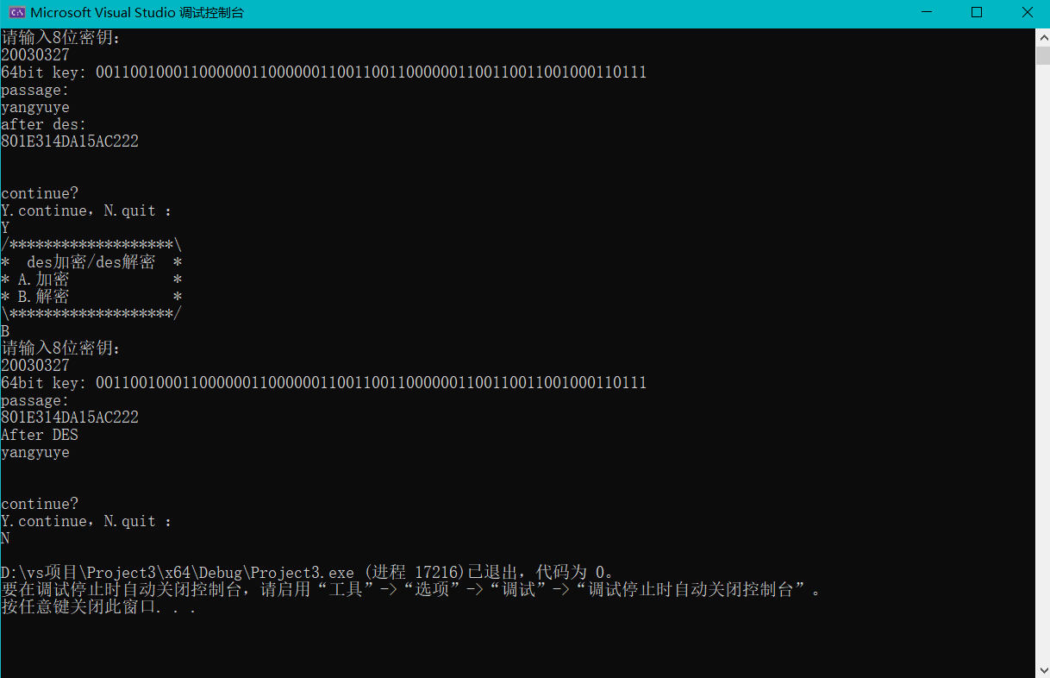
三、实验中遇到的问题及解决方案
在反复遍历数组时容易因为忘记不同的数组意义而使遍历栈溢出，或遍历次数不够导致在接下来的计算中引用未定义变量。
可以改用sizeof()确定数组遍历次数，或者改用更易识别的名字作矩阵名

实验三 RSA 双钥密码算法实现
一、实验目的
掌握公钥密码体制一般原理；掌握 RSA 算法的基本原理；了解素数判定、幂模、模逆 等大数运算的算法；了解公钥加密体制的优缺点及其应用方式；理解双钥密码体制在网络 安全通信中的作用。二、实验内容、代码和结果
1、题目：
1. 编程实现 RSA 公钥密码算法密钥对生成。
2. 编程实现 RSA 公钥密码算法加密、解密过程。

代码：
//
// Created by Administrator on 2023/11/21.
//
#include <iostream>
#include <cmath>
#include <cstdlib>
#include <ctime>
#include <string>
int gcd(int a, int b) {
if (b == 0)
return a;
return gcd(b, a % b);
}
bool isPrime(int num) {
if (num <= 1)
return false;
for (int i = 2; i <= sqrt(num); i++) {
if (num % i == 0)
return false;
}
return true;
}
int generateRandomPrime() {
int prime;
do {
prime = rand() % 100 + 1;
} while (!isPrime(prime));
return prime;
}
int modInverse(int a, int m) {
int m0 = m, t, q;
int x0 = 0, x1 = 1;
if (m == 1)
return 0;
while (a > 1) {
q = a / m;
t = m;
m = a % m;
a = t;
t = x0;
x0 = x1 - q * x0;
x1 = t;
}
if (x1 < 0)
x1 += m0;
return x1;
}
// 加密
int encrypt(int message, int e, int n) {
int cipher = 1;
for (int i = 0; i < e; i++) {
cipher = (cipher * message) % n;
//std::cout<<"cipher: "<<cipher<<std::endl;
}
return cipher;
}
int decrypt(int cipher, int d, int n) {
int message = 1;
for (int i = 0; i < d; i++) {
message = (message * cipher) % n;
}
return message;
}
// 生成随机互质数
int findCoprime(int n) {
while (true) {
int e = rand() % (n - 2) + 2;
int gcd1 = gcd(e, n);
if (gcd1 == 1) {
return e;
}
}
}
void run() {
srand(time(0));
int p, q, n, phi, e, d;
int message, encrypted, decrypted;
std::cout << "Generating random prime numbers (p and q)..." << std::endl;
p = generateRandomPrime();
q = generateRandomPrime();
std::cout << "p=" << p<<";q="<<q<<std::endl;
n = p * q;
phi = (p - 1) * (q - 1);
e=findCoprime(phi);
std::cout << "auto random e=" << e<<std::endl;
d = modInverse(e, phi);
std::cout << "Public key (n, e): (" << n << ", " << e << ")" << std::endl;
std::cout << "Private key (n, d): (" << n << ", " << d << ")" << std::endl;
std::cout << "Enter a message to encrypt: ";
std::cin >> message;
encrypted = encrypt(message, e, n);
decrypted = decrypt(encrypted, d, n);
std::cout << "Encrypted message: " << encrypted << std::endl;
std::cout << "Decrypted message: " << decrypted << std::endl;
}
int main(){
while (1){
std::string s;
std::cout << "Continue?(y or else)";
std::cin>>s;
if(s=="y")
run();
else
return 0;
}
}

实验结果（抓屏）：
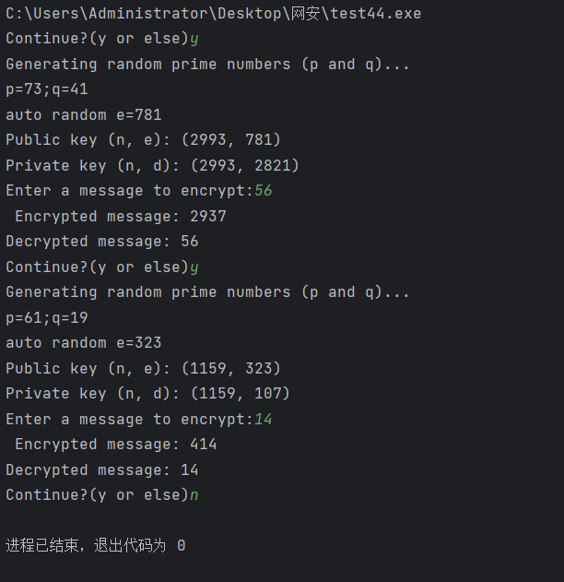
三、实验中遇到的问题及解决方案
当数值过大时容易产生数值溢出等问题应该考虑使用long等数值上限更大的数据类型，或者考虑使用char[],将每一个char类型的ASCII值进行加密可以规避数值溢出的问题

